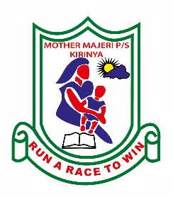**MOTHER MAJERI NURSERY SCHOOL**

**END OF TERM II EXAMINATION, 2024**

**CLASS : BABY CASS**

**SUBJECT: GENERAL KNOWLEDGE**

**My name is ________________________________stream_____**

**1. Shade important people.**

|  |  |
| --- | --- |
| Mother and Child | How To Draw A Man In A Suit Ehow, 56% OFF | toi.tarnow.pl |
| Teacher Line Drawing PNG Images - Pngtree | |

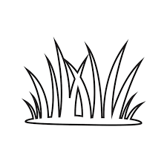**2. Match the same pictures.**

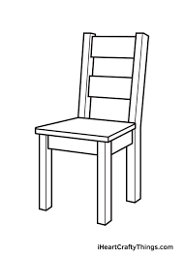

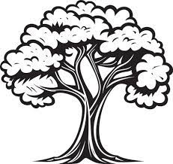

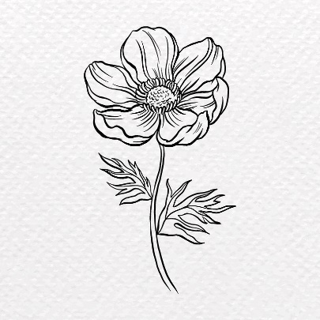

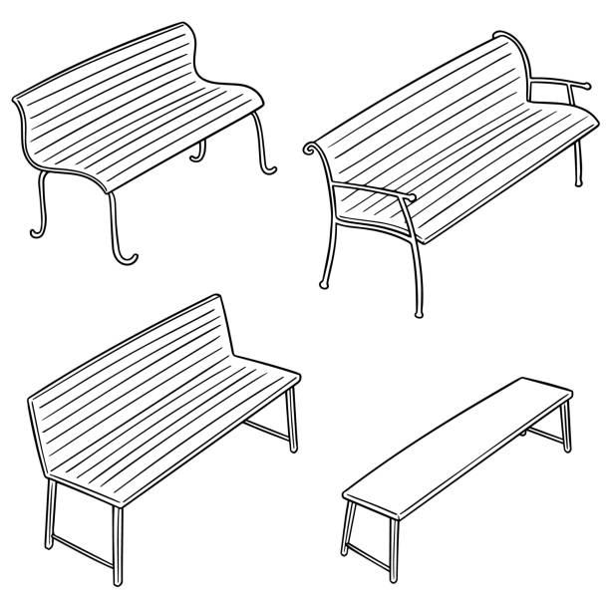









**3. Draw the same picture.**

|  |  |  |
| --- | --- | --- |
| Stick Figure Kids Vector Art, Icons, and Graphics for Free Download |  | Shop Tree Outline Drawing | UP TO 51% OFF |
|  |  |  |

**4. Circle the body parts.**

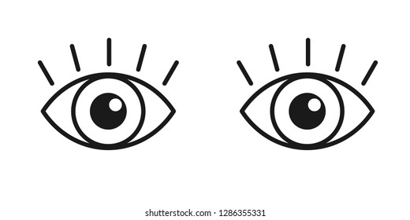

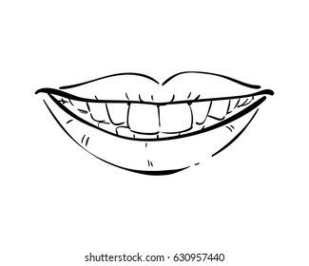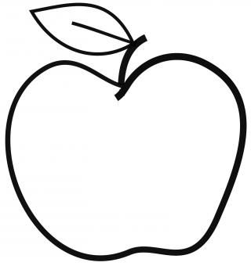

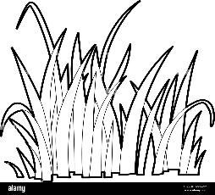

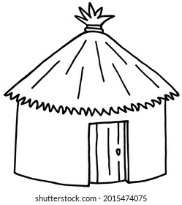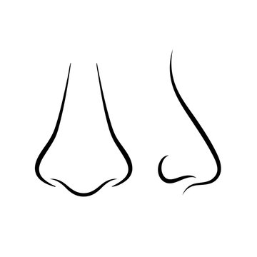

**5. Match the same pictures.**

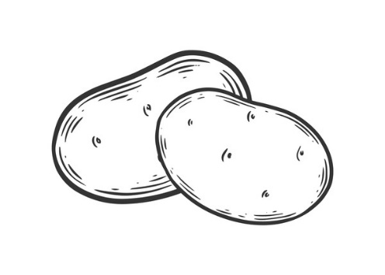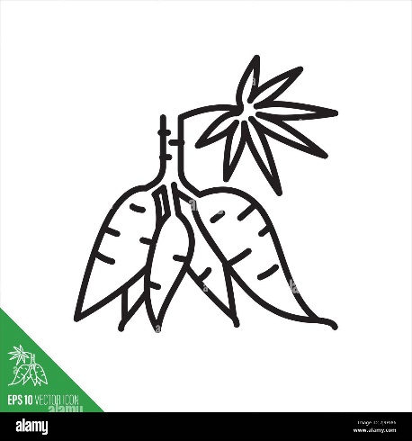

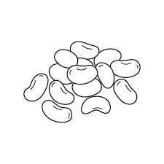

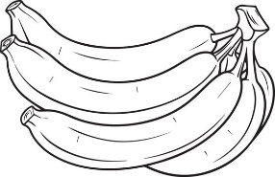

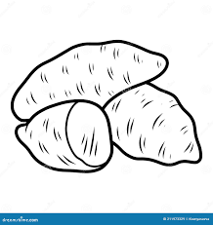

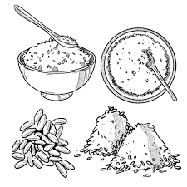

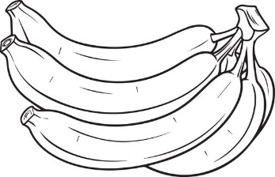











**END**